

2022

Summer



**Welcome to Summer!**

As things get back to normal we are delighted to put on a more ‘normal’ set of activities this year. We know times are tough and everyone is feeling the pinch so we have tried to choose a good mix of activities to suit most budgets.

Booking is slightly different this year, so check below on how to book and pay.

**How to book and pay.**

· Check through the booklet, decide what you want to do, fill in the **BOOKING FORM** and return it to us by post, or drop it in when we are at Norfolk First Credit Union by the **BOOKING DEADLINE of Friday 24th June.**

· If you want to stay on the mailing list for next year you must also send back your **MEMBERSHIP FORM.**

· After the booking deadline we will allocate spaces on the trips and send you a confirmation along with the total you need to pay.

· You must make the payment either by BACS or by cash by visiting us at Norfolk First Credit Union by the **PAYMENT DEADLINE of Friday 15th July.**

· We will then send out final confirmations and pick up times and we’re all set to go.

Spaces will be allocated to people who get their forms in by the **BOOKING DEADLINE**. If a trip is full you will be placed on the reserve list. There may be spaces available after the booking deadline, you can email me scott.porter@henderson-norwich.org to check.

**BOOKING DEADLINE - Friday 24th June**

Then wait to receive you confirmations with total amount to pay, and pay by the

**PAYMENT DEADLINE - Friday 15th July**

**Membership Forms**

Due to data protection regulations (GDPR) you need to give consent for us to store your information. You will need to complete a membership form with the details of the people going on the trips and return it with your booking form. Please make sure you tick the boxes giving us permission to store your data. We only store the data for one year and use it to mail out your programmes, nothing else. More details and terms and conditions for the trips are on the membership form.

**Booking / Paying in Person - Norfolk First Credit Union**

Someone will be at Norfolk First Credit Union on Tuesdays and Wednesdays between 10am and 12pm from Tuesday 14th June to Wednesday 6th July to book or pay in person.



**BOOK ONLINE**

Scan the QR code with your phone, fill in the forms and we will email you out the confirmations with the total amount to pay after the Booking Deadline



**FOLLOW OUR FACEBOOK**

We have a new Facebook group for the trips. Scan the QR code below or search Facebook for **Family Fun Sorted**



**Scan To Book**

**Take me to Facebook!**

**GENERAL TERMS AND CONDITIONS**

Henderson Trust attends venues and uses transport providers that have in place their own risk assessments and health and safety procedures. By signing up to the trips you are agreeing to these procedures. If you are attending a trip that has no formal procedures (such as a beach trip for example) Henderson Trust will make all reasonable provision to ensure the activity is safe but all attendees participate in these trips at their own risk. If you require details on health and safety or risk assessment for a particular trip, then please let us know.

Henderson Trust takes no responsibility for any loss or damage to personal items that are brought on any trips.

By signing up to trips organised by the Henderson Trust’s Sorted Programme you are agreeing to follow the terms and conditions stated on the membership form. For full terms and conditions please visit our website www.henderson-norwich.org or visit our Facebook page @HendersonTrust.

**Send completed BOOKING and MEMBERSHIP forms to**

**Summer Sorted, Henderson Business Centre, 51 Ivy Road, Norwich, NR5 8BF**

Or drop them into Norfolk First Credit Union in West Earlham on Mondays or Tuesdays between 10am and 12pm from Tuesday 14th June to Wednesday 6th July or book online by scanning the QR code or visiting [https://form.jotform.com/221313501046035](https://l.facebook.com/l.php?u=https%3A%2F%2Fform.jotform.com%2F221313501046035%3Ffbclid%3DIwAR2nR0-zeWtswwPMytF94pgSTgCkCz7glElK_NSSXJWy70RtWcDF9raeNAU&h=AT2z3R4H4_NwmKYPTzy9je7shWh__ehAYYr7hE0oBAZURDWj99qwcRs-IDR53vC2SInbN8u7XLc4Ils3wyUU4-FyzFgdtCP10eSFzgng6bxYdc8tnHwMvzMGqRDAQAAsq7g2dg)

**BOOKING DEADLINE - Friday 24th June**

**PAYMENT DEADLINE - Friday 15th July**

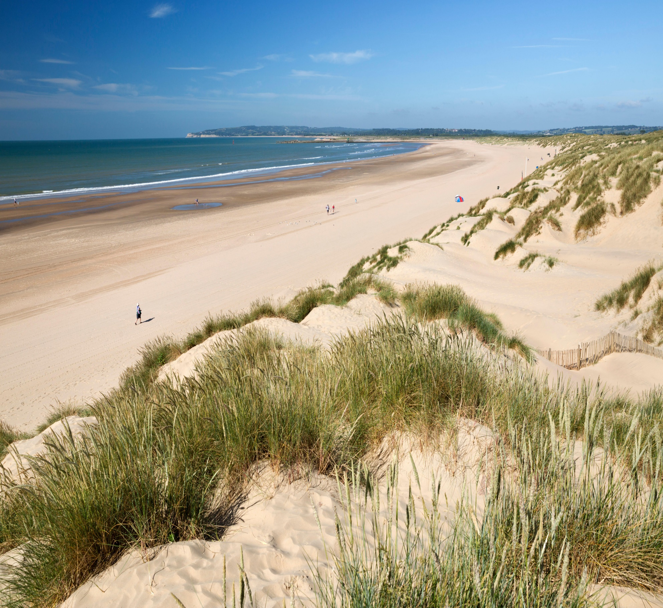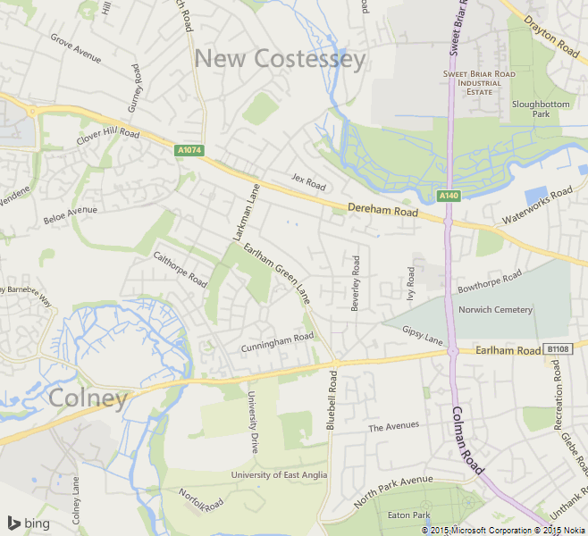

**Dereham Road**

Bus stop opposite Aldi.

(SE-bound)

**West Earlham Pick Up**

Bus stop outside School

on Earlham West Centre

**Fourways (THE ONE80) Pick Up**

Stevenson / Clover Hill Road

**EARLHAM ROAD**

**GUARDIAN ROAD**

Aldi

**DEREHAM ROAD**

**Catchment Area and Pick Up Points**

**SORTED** is part of Henderson Trust which is a registered charity. We can only offer the trips to those living in our area of benefit. The area is highlighted on the map below but is generally speaking the **NR5 8 postcode**. All trips will have the same pickup and drop off points as shown below.

**Travel**

COVID 19 - All travel is used within the current guidelines, which may change at short notice before or during the Summer trips.

Please note that ALL children under the age of FOUR require either a car or booster seat appropriate to their requirements. NO children to travel on laps. The parent/guardian is responsible for the child being seated correctly.

If you do not have the correct seat you may be refused entry to the bus.

**NO unaccompanied children (18 years and under) will be taken.**

If you have any specific requests regarding seating on the coaches please contact us and we will do our best to accommodate.



**What’s On?**

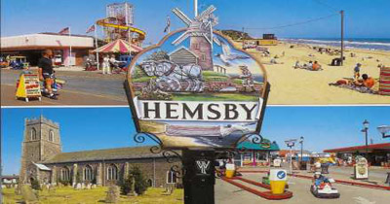

**Wednesday 3rd August - Hemsby Beach**

**Approximate Time - Leave 10am - Back By 5pm**

With its beautiful beach, arcades, fair ground, go-karting and a free soft play area, Hemsby has proven to be very popular. Rain or shine there will be something to do for all the family.



**Wednesday 10th August - Sea Palling Beach**

**Approximate Time - Leave 10am - Back By 5pm**

We love Sea Palling with its rock pools and sandy beach to explore. Close to the beach are the amusement arcade, playing field, café, farm shop and one of the best fish and chip shops in the area.

**Thursday 4th August - Pettits**

**Approximate Time - Leave 10am - Back By 5pm**

With new rides and attractions for 2022 Pettitts is becoming evermore popular with Sorted families.

Join us to see the animals or ride the train around the park. The main rides are all included in the price. With live shows, animals and rides, Pettitts is known as one of Norfolk’s premier parks.

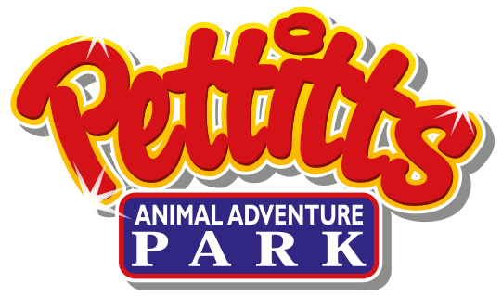

**Monday 8th August - Cadge Road**

**Approximate Time - 10am - 2pm**

Just a get together at Cadge Road, with food and activities, That’s it! We wanted to put on something very informal and relaxed at no cost to families. We will lay on games, activities and some food. A chilled day for all. And it’s free! Please book so we have an idea of numbers to cater for.

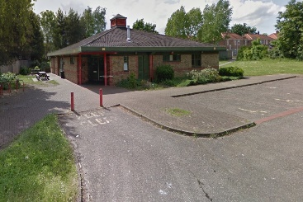

**Fun Day**



**Thursday 11th August - Bewilderwood**

**Approximate Time - Leave 10am - Back By 5pm**

A huge award-winning forest of family fun and outdoor adventure with treehouses, zip wires, jungle bridges, Crocklebogs, Twiggles and Boggles, storytelling and boat trips. And the new Towering Treetop Tangles! Scramble in the tangles as you climb around and explore the new area.



**Thursday 18th August - Africa Alive!**

**Approximate Time - Leave 10am - Back By 5:30pm**

With thousands of animals from around the world, set in over 100 acres of stunning Suffolk countryside, Africa Alive Zoological Reserve is the perfect place to connect with nature. Certainly one of the best Zoos in the region with lots to see and a great play area!



**Wednesday 17th August - Cromer Beach**

**Approximate Time - Leave 10am - Back By 5pm**

Once we arrive in Cromer feel free to explore the local shops, pier, arcades or lifeboat museum. Or simply sit back and relax on the beach. And it’s Carnival Day! So there will be lots going on in the town.

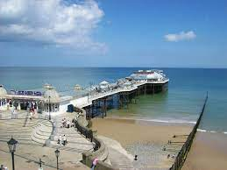

**Monday 15th August - Cadge Road**

**Approximate Time - 10am - 2pm**

Just a get together at Cadge Road, with food and activities, That’s it! We wanted to put on something very informal and relaxed at no cost to families. We will lay on games, activities and some food. A chilled day for all. And it’s free! Please book so we have an idea of numbers to cater for.



**Fun Day**

**Monday 22nd August - Great Yarmouth**

**Approximate Time - Leave 10am - Back By 6pm**

Lots to see and do in Great Yarmouth. Two piers, a seafront full of activities, Regent Street shopping and huge sandy beach. You’ll be spoilt for choice on how to fill your day.

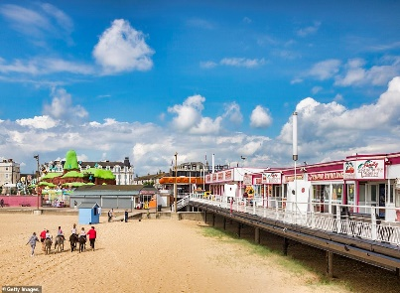

**Circus** - This spectacular family show includes amazing circus acts from all around the world. Adults and Children need a seat, under 3’s can go on your lap. **Doors open at 2pm**

**Great Yarmouth—Extras**

Want more to do? Book one or both of the following activities. **You will also need to book the bus.**



**Friday 26th August - Roarr!**

**Approximate Time - Leave 10am - Back By 5:30 pm**

We love Roarr! And it keeps getting better. Predator High Ropes, dinosaur trails, animals, large indoor play area and Dippy’s Splash Zone (please bring spare clothes and a towel for the splash zone).



**Thursday 1st September - Pleasurewood Hills**

**Approximate Time - Leave 10am - Back By 6pm**

The Summer Sorted programme wouldn’t be complete without our annual trip to end the summer holidays at Pleasurewood Hills. There is also a new ride called the Egg-Spress!

With over 35 rides and attractions, plus sea lion and parrot shows, it’s definitely a trip you won’t want to miss.



**Great Yarmouth—Extras**

Want more to do? Book one or both of the following activities. **You will also need to book the bus.**



**Pleasure Beach** - A mixture of high-octane rides and traditional attractions for all the family. Your wristband will give you unlimited access to 25 rides for the day including the 4D cinema. **Tickets are for 11am to 2pm**

**Wednesday 31st August - Gorleston Beach**

**Approximate Time - Leave 10am - Back By 5pm**

A stunning bay with a huge, wide curving, sandy beach with ramp access. With adjoining shops, cafes, amusements and amenity area, everything you need is close by.

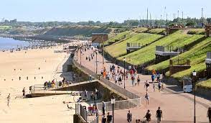

**Wednesday 24th August - Hirsty’s Maize Maze  
Approximate Time - Leave 10am - Back By 4pm**

Hirsty’s is a real family fun day out. You’ll have hours of fun wandering around the mega maze. Meet the farmer and let him take you on a tractor and trailer ride around the farm or race your family and friends in the go-karts. There is also a large play area and zip-wire plus a Crazy Croquet course.



**Coach Rules**

**Be on Time**

Try to be at your stop 5 minutes early. You might have to wait for us to arrive (mainly due to traffic) but it’s better than missing the bus, if you are late we won’t wait! Same goes for the return journey, be aware we have left people behind before!

**Sit Down and Belt Up!**

It’s the law! If you (or someone in your care) is caught without your seatbelt on YOU and the driver will both be fined. If you are not sitting down with your seatbelt on, the driver has the right to pull over and ask you to get off.

**Same Seats Out and Back.**

Please sit in the same seats for the trip there and back. People may have left things on or near their seats and if you don’t sit in the same seats it can upset people and cause confusion when we check who’s on the bus.

**No Swearing.**

There are small children on most of the busses, please just don’t do it!

**No Alcohol.**

Pretty self explanatory. We may ask you to get off the bus if you are drinking alcohol, or not let you on if you are drunk!

**No food on the coach - *NEW***

Due to the new coach company rules, there will be no eating allowed on the coaches.

**Wear Headphones - *NEW***

If you are going to use phones, tablets or whatever to play games, watch movies or anything else then please use headphones. Not everyone on the bus has the same taste!

**Code of Conduct**

All young people, families, staff and volunteers must act and treat everyone in the way that they would like to be treated themselves. Inappropriate behaviour will not be tolerated and may lead to an individual or families being refused attendance on further activities. On the Family trips, Parents/Carers remain responsible for children and young people in their care at all times. All activities are alcohol and drug free. **In fairness to other families, at the end of each family trip, everyone must return to their coach on time.**



**Summer Sorted, Henderson Business Centre, 51 Ivy Road, Norwich, NR5 8BF**