

EASTER

2022



**Family**



Easter Sorted

**We Are Back!**

And delighted to be able to put on a programme of subsidised activities for the Easter holiday, making your Family Easter

**What to Do**

This booklet contains all the information you need to book your trips. Read through the booklet and find out about what trips are on offer and then fill in your booking forms. Send the forms back to us with payment and we will book you in and send out confirmations and pick up times after the final booking deadline

The booking deadline is Friday 18th March - We must have received bookings and payments by then - Spaces are limited so please book as soon as you can.

When you receive your conformations you just need to check everything is correct and be at the bus pick up point 5 minutes before the pick up time - Everything else is Sorted!

**Anyone under 18 must be accompanied by an adult.**

**Cancellations, Late Bookings and Refunds**

We are only able to refund money for cancellations if you let us know at least **48 hours before the trip leaves.**

We may also have places left on trips after the booking deadline, please contact us for more details - **01603 251766 or email sorted@henderson-norwich.org** Please leave a message if you can’t get through and someone will get back to you as soon as they can.

If you have cancelled or booked on a trip that is full we will refund you as soon as possible.

**The deadline for bookings and payment is 18th March**

**Friday 18th March**



All payments must be completed by the deadline, there are numerous ways to pay all of which are stated below. If you have difficulty paying **PLEASE** come and talk to us to arrange a payment plan to help spread out the cost.

**BY Bank Transfer**

You can pay by bank transfer (BACS):

Account Name - Henderson Trust

Account Number - 60190926

Sort Code - 20-62-57

**Important** - Please use your family name as your payment reference and write on your booking form that you are paying by BACS. You can post the booking form to our office at: Easter Sorted, Henderson Business Centre, Norwich, Norfolk, NR5 8BF.

**IN PERSON**

Someone will be in Norfolk First Credit Union (located opposite the doctors surgery in West Earlham, NR5 8AD) collecting forms and cash payments as well as answering any questions at the following times:

**9.30am till 12:30pm Tuesday and Wednesday, 7th March to 17th March.**

So if you need any help with the forms, or just fancy a chat, pop in.

Paying for your trips

**Deadline Thursday 14th March **



**Family**



What’s On?

**Monday 4th April - Hippodrome Circus - Pirates Live**

**Adults - £14 Children - £14. Under 3’s (on lap, no seat) £6.**

Come aboard to see the latest live action water show, Pirates Live staring Jack Jay, Johnny Mac and their team. Hippodrome Circus is always one of our most popular trips and never disappoints our entertainment expectations. This immense production brings together a motley crew of pirates, fire eaters, acrobats, aerialists and hilarious comedy in an experience like no other.



**Thursday 7th April - Strikes Dereham - Bowling**

**Adults - £7.50. Children - £7.50. Under 3’s £N/A.**

This will be a combined trip with Planet Zoom (see below) so you can choose which activity you would like to do. Both activities are in the same building. You will get 2 full games to attempt those strikes. Whether you're a first-timer or bowling pro, ten pin bowling at Strikes is always an action packed and fun day out. With the latest equipment to-hand, including lane bumpers, ball ramps and light weight balls for the young ones, Strikes is an activity families can enjoy together.

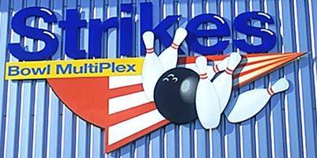

**Thursday 7th April - Planet Zoom - Dereham - Soft Play**

**Adults - £3. Children - £6. Under 3’s £6.**

This will be a combined trip with Strikes (see above) so you can choose which activity you would like to do. Take off for Planet Zoom for the softest and squidgiest landing! We will have an hour EXCLUSIVE HIRE of the venue so that means 3 levels of tunnels, snake slides, and soft play activities all to ourselves including the toddler area. There is also a seating area with hot and cold refreshments available.

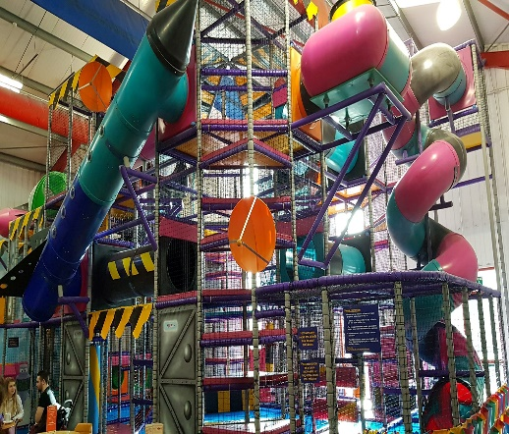

**Monday 20th August - Swimming at Thetford**

**Prices**

Breckland Leisure Centre & Waterworld offers a 25m pool with waves, rapids and a flume, so get your bathers on and jump in. We will be joining the public session and you will have 90 minute to swim, splash about and whizz down the sides.

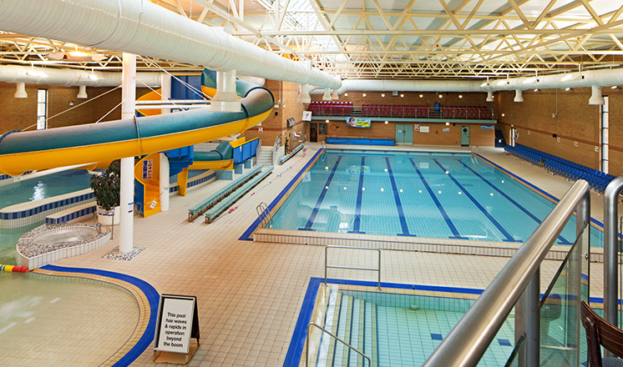

**Family**

And that’s your

For Easter



Please note that all children under the age of four will require either car seats or booster seats. This is a requirement of the coach companies.

**NO CHILD WILL BE ALLOWED TO TRAVEL WITHOUT ONE IF NEEDED.**

For Family trips parents/carers remain responsible for children and young people in their care at all times. **NO** unaccompanied children (18 years and under) will be taken.

For 10-16 trips parents or carers are **NOT** required to stay with their children for the duration of the activity. However, parents or carers **MUST**, as part of the booking process, complete a parent/carer consent form for each child attending one of these activity sessions. (This is only if you have not already done so as part of your membership).

**WHAT TO DO NOW?**

We have enclosed the booking forms for the Easter holiday activities, you should now:

· Read the programme of activities and choose the activities you would like to attend.

· Complete the booking forms.

· Return these forms and payment to us before the cut off of **Thursday 14th March** (for details on how to pay see page 2).

· We will then send out confirmations and pick up times.

Don’t forget to choose the correct pick up location that suits you. and your family and put it at the top of your booking form

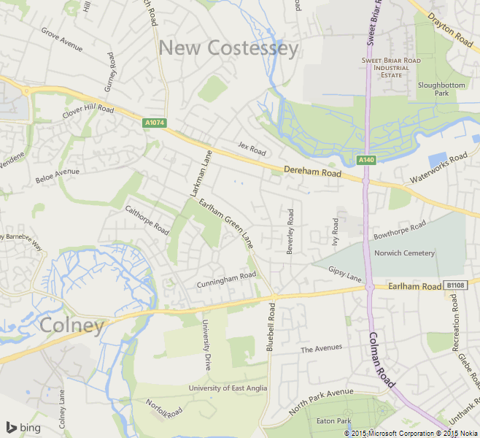

**Dereham Road**

Bus stop opposite Aldi. To the city side

**West Earlham Pick Up**

Outside School on Earlham West Centre

**Fourways (Monkey Island) Pick Up**

Stevenson / Clover Hill Road

**EARLHAM ROAD**

**GUARDIAN ROAD**

Aldi



Important Information

Deadline Thursday 14th March



**Henderson Business Centre**

**51 Ivy Road**

**Norwich**

**NR5 8BF**